Lesson 5: Activity 1 “Expected Value”
Name:________________________________ Hour:_______

Directions: Below are three mystery discs. One of the discs is fair, one is skewed toward the house, and one for the player. Participants must pay $1.00 for each spin. In the space below the pictures calculate the expected value for each mystery disc. Indicate below each picture if the disc is fair, player, or house-skewed.

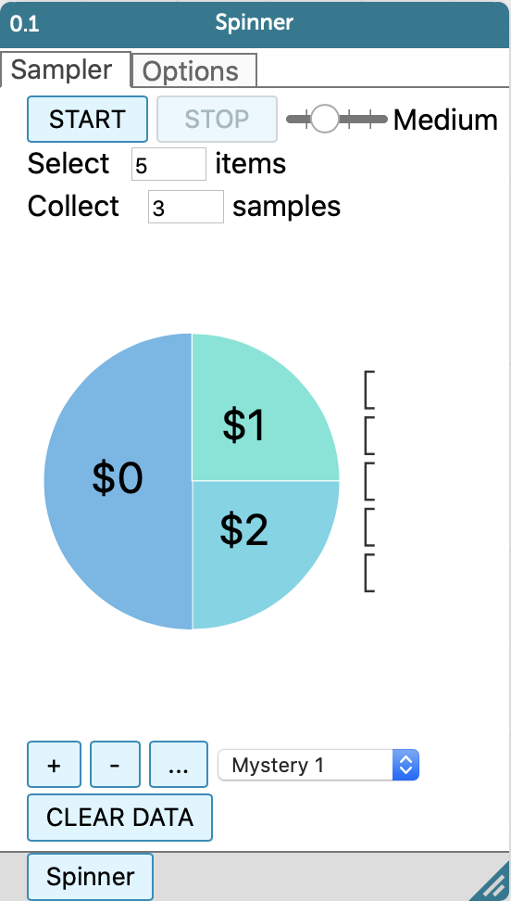 |  | 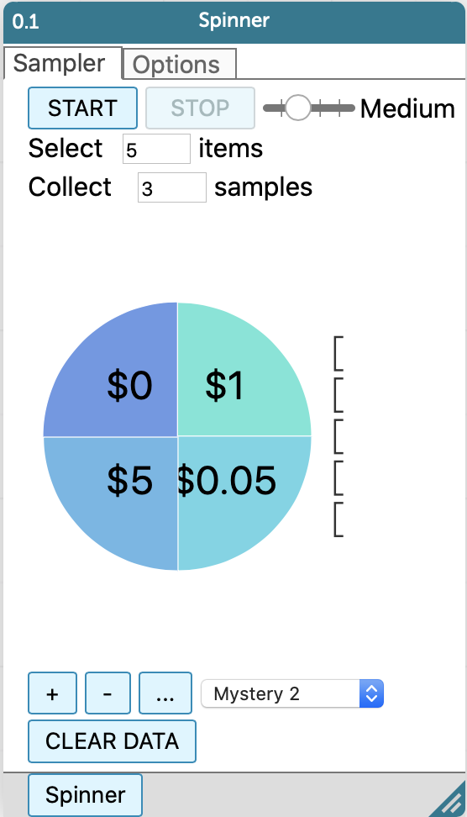 |  | 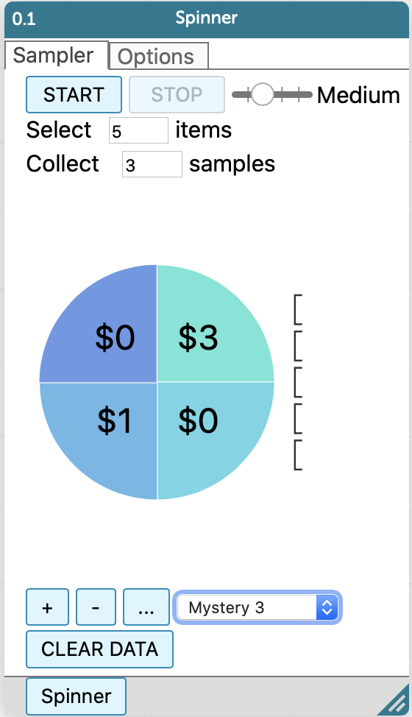
Mystery Disc 1: Expected Value Calculations (show work below): Expected Value = ________
Mystery Disc 2: Expected Value Calculations (show work below): Expected Value = ________
Mystery Disc 3: Expected Value Calculations (show work below): Expected Value = ________

