Carnival Game Tycoon Lecture Notes: Lesson 5 Name:__________________
Delta College STEM Explorer Hour:______

- Expected Values
  - Defined: The _____________________ of a game is sum of all of the ___________of each value of each outcome and the corresponding probability of that outcome.

  - Formula: ______________________________________until ______outcomes are accounted for

    - X= the ____________ of the outcome
    - P= the ________________of the outcome

  - Application to Games:

    - Knowing the Expected Value is important for planning ______________ games or determining if games are worth __________________.

    - Example “Spinner Game”

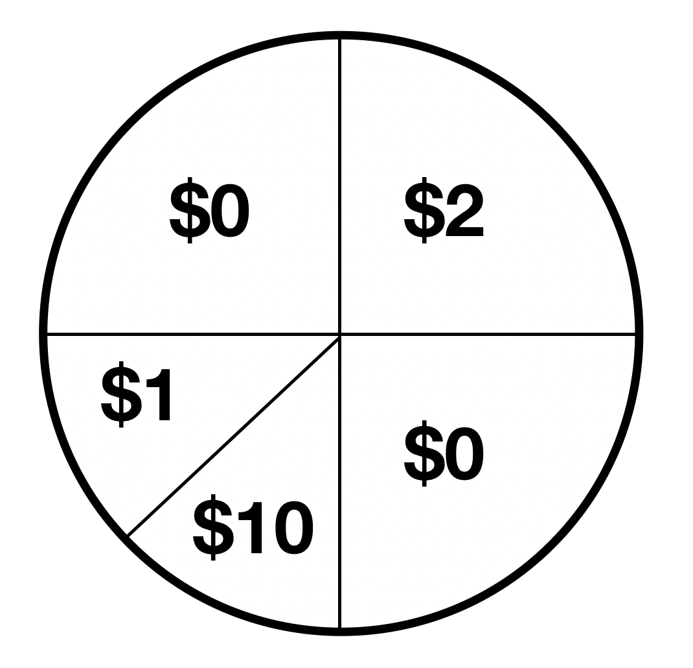

    - Use of _____________

    - Solving for E (Expected Value):

    - ______________ of the Expected Value #: In this scenario, the Expected Value of _______ means that you can ______________ to win on average $.875 per __________________. This is a ___________ game for the player and a _________ game for the house.

